**VISUALISATION URL:**

**DATA VISUALISATION 2 REPORT**

**Domain**The domain is the world’s best ranking restaurants in the world crossing over with Michelin star.

**Purpose**The visualisation will explore the food scene with what it takes to get a Michelin star and whether the top 50 restaurants in the world in 2018 and 2019 have Michelin stars or not. It will also explore the diverse cultures of food and show what are the trending cuisines.

**Audience**The targeted audience would be food critics, food lovers, tourists, and people in the food industry.

**Dataset**  
Top 50 best restaurants in the world 2018:  
<https://www.kaggle.com/mmayur/the-worlds-50-best-restaurants>  
Top 50 best restaurants in the world 2019:  
<https://www.kaggle.com/giuseppefumarola/world-best-50-restaurants-2019>  
Michelin restaurants in the world:  
<https://www.kaggle.com/jackywang529/michelin-restaurants?select=two-stars-michelin-restaurants.csv>

**Processing Data**Datasets that had the 50 best restaurants in the world for 2018 and 2019 were combined and given the same columns (attributes). Using an online Reverse Geocoding tool, the longitude and latitude were fed through, and the countries of each restaurant were found.   
<https://www.geoapify.com/tools/reverse-geocoding-online>  
The Michelin star csv’s originally were separated into three csv’s, one for each Michelin star, which were then combined into one csv for easier data access.

**BIBLIOGRAPHY**

**APPENDIX**

1. **FDS SHEET 1**

1. **FDS SHEET 2**

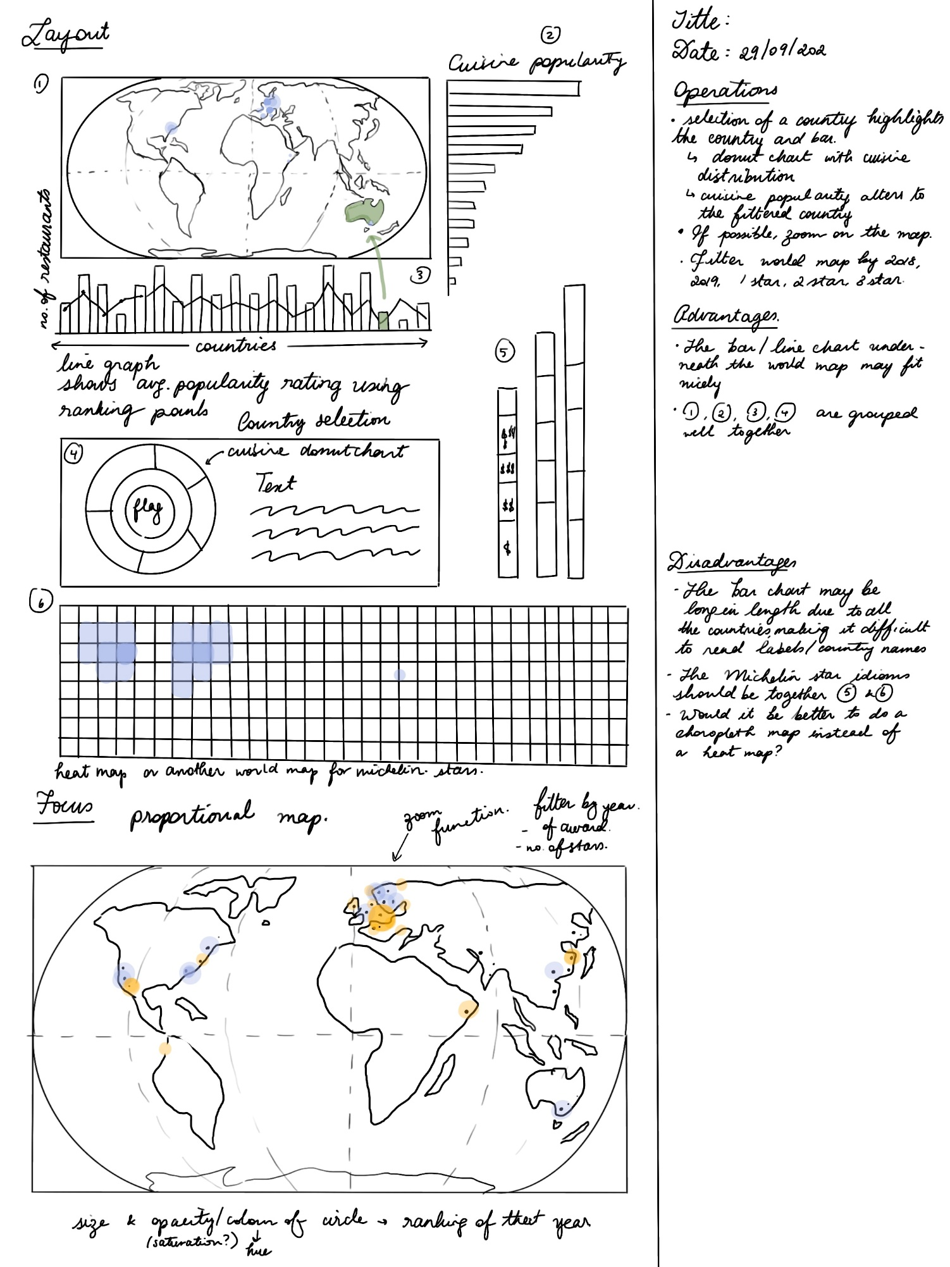

1. **FDS SHEET 3**

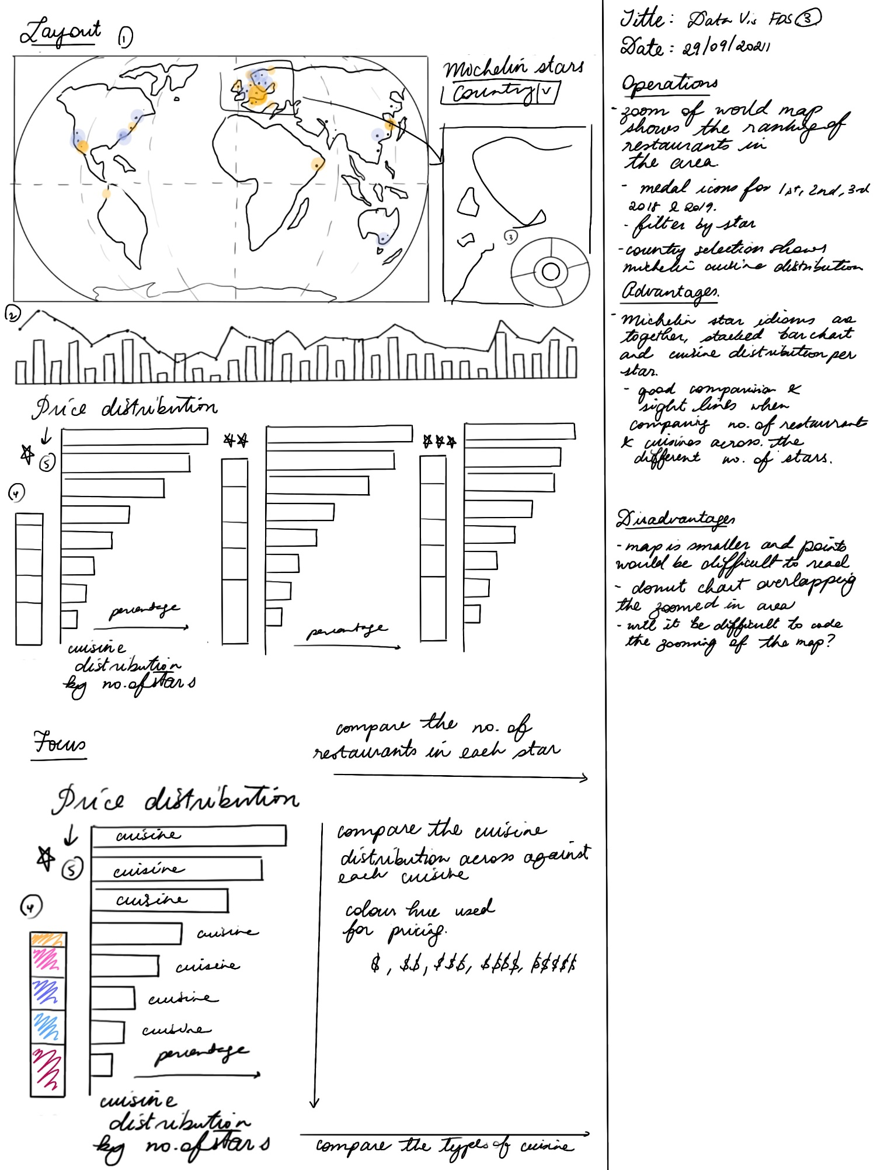

1. **FDS SHEET 4**

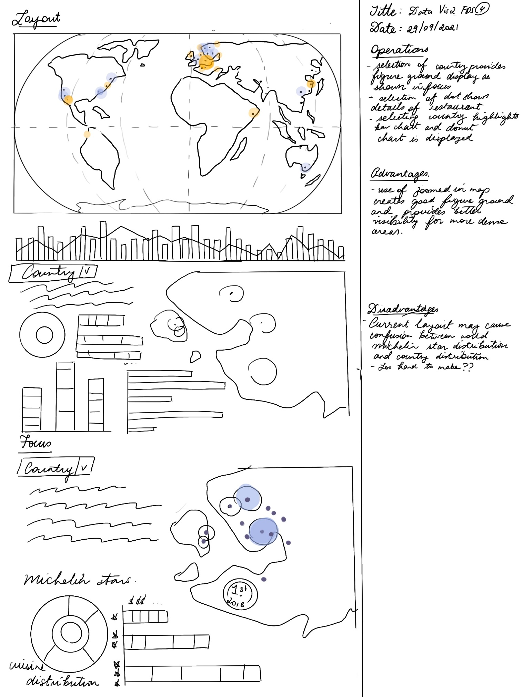

1. **FDS SHEET 4.2**

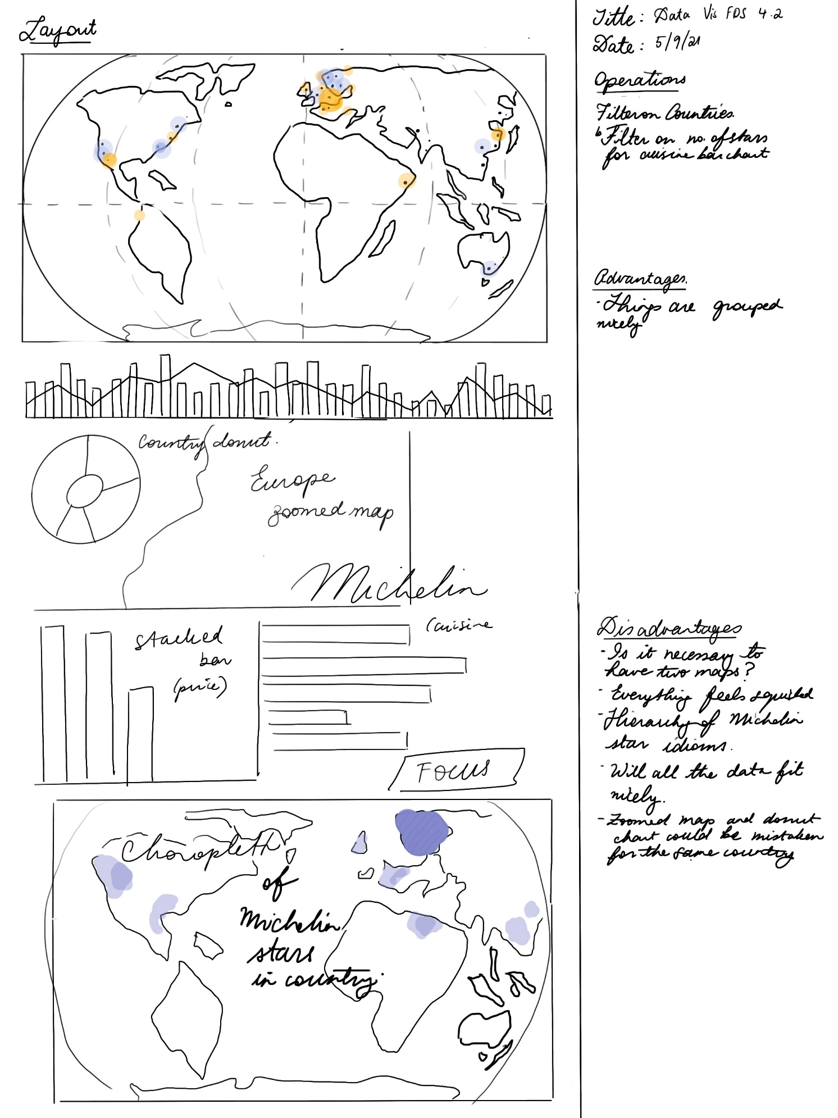

1. **FDS SHEET 4.3**

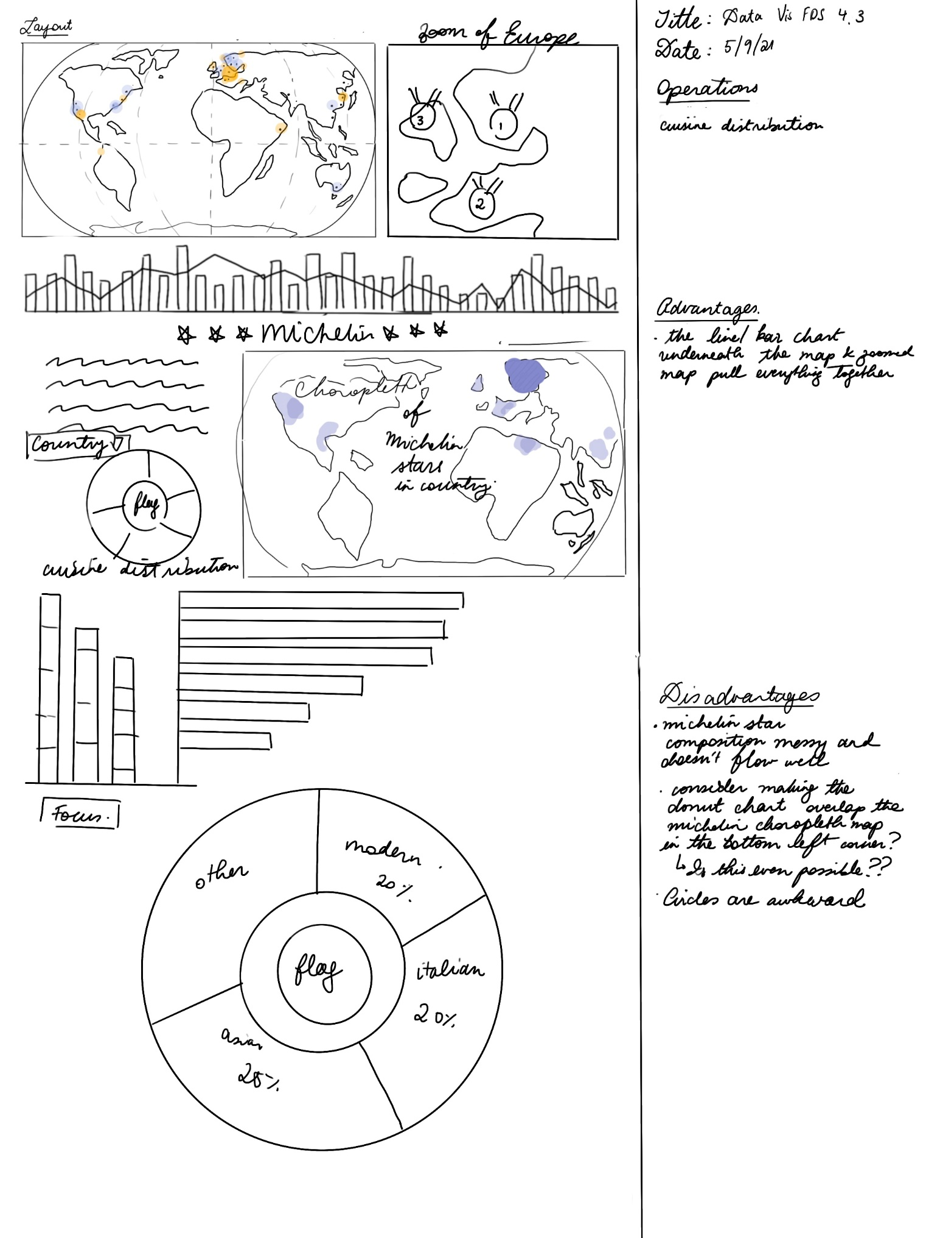

1. **FDS SHEET 5**

